**UNITY III**

**ACTIVITY 1**

**DESCRIPTION OF MEALS AND MENU**

**JULIETH CATHERINE ORTEGA MENDOZA**

**COD: 1049636518**

**TUTOR**

**LILIANA HERNANDEZ AMADO**

**UNIVERSITY FOUNDATION SAN MATEO**

**BASIC ENGLISH MODULE**

**SAFETY AND HEALTH ENGINEERING FOR WORK**

**2019**

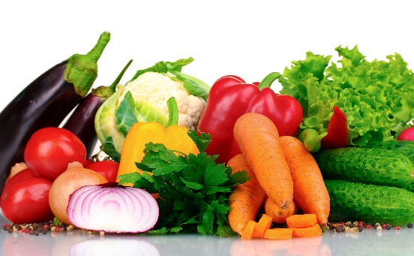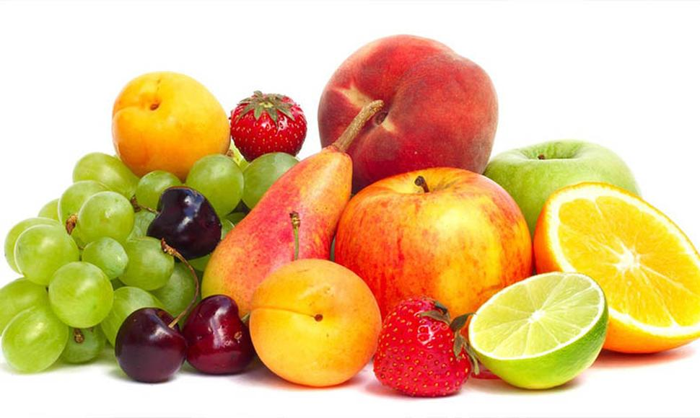

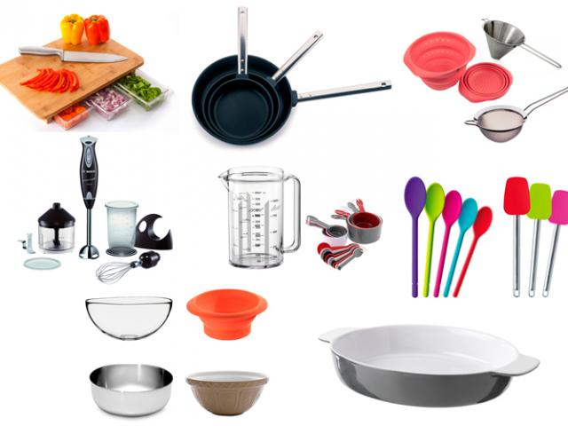

**FRUITS – VEGETABLES – UTENCILS**

**AUDIO**

<https://www.dropbox.com/s/rn13mhrtk4j999p/fruits%2Cvegetables%2Cutencils.mp3?dl=0>

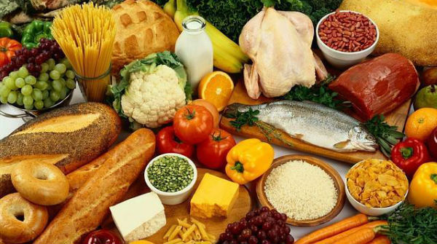

**FAVORITE FOODS**

**AUDIO**

[**https://www.dropbox.com/s/g9w0nqxk76z3xu4/favorite%20foods.mp3?dl=0**](https://www.dropbox.com/s/g9w0nqxk76z3xu4/favorite%20foods.mp3?dl=0)